**SQL Developer Internship Documentation**

**Creating & Using Views for Student Scores**

**Objective**

This task focuses on simplifying data analysis by using SQL views to store reusable query

logic.

**Project Steps:**

**1. Setup Database & Tables**

Create and populate tables (e.g., students, scores).

# creating and use database

USE StudentManagement;

# Create table for students

CREATE TABLE students3 (

student_id INT PRIMARY KEY,

name VARCHAR (100)

);

# Create table for scores

CREATE TABLE scores (

student_id INT,

subject VARCHAR (100),

score INT,

FOREIGN KEY (student_id) REFERENCES students3(student_id)

);

# Insert data into students table

INSERT INTO students3 (student_id, name) VALUES

(1, 'Alice'), (2, 'Bob'), (3, 'Charlie'), (4, 'Daisy'), (5, 'Ethan'),

(6, 'Fiona'), (7, 'George'), (8, 'Hannah'), (9, 'Ian'), (10, 'Jane');

# Insert data into scores table

INSERT INTO scores (student_id, subject, score) VALUES

(1, 'Math', 45), (1, 'Science', 50), (2, 'Math', 35), (2, 'Science', 42), (3, 'Math', 40),

(3, 'Science', 41), (4, 'Math', 39), (4, 'Science', 47), (5, 'Math', 60), (5, 'Science', 55),

(6, 'Math', 50), (6, 'Science', 70), (7, 'Math', 30), (7, 'Science', 20), (8, 'Math', 50),

(8, 'Science', 60), (9, 'Math', 49), (9, 'Science', 40), (10, 'Math', 45), (10, 'Science', 30);

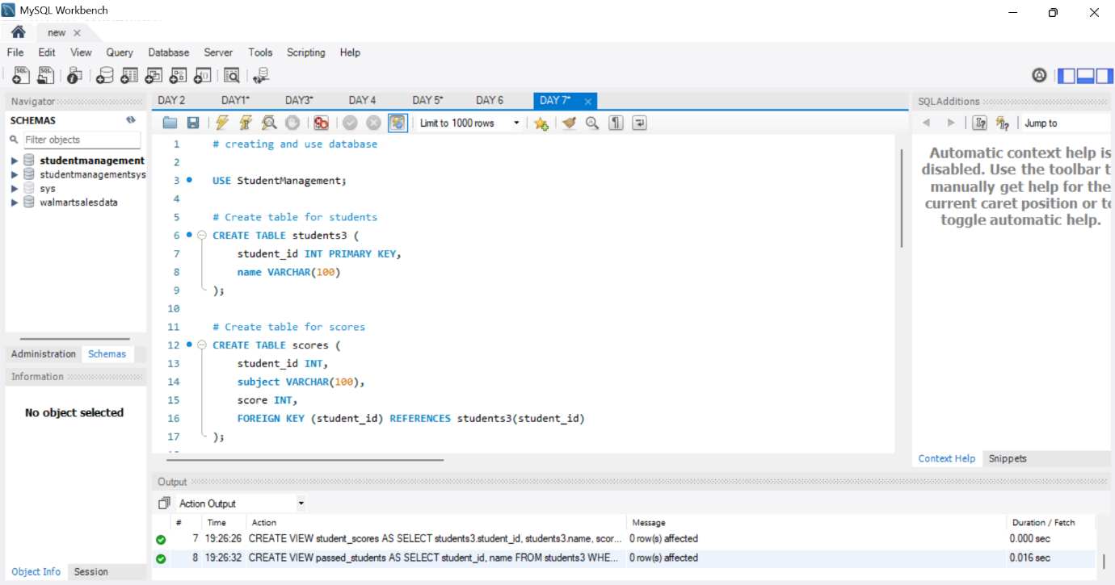

**2. Tasks to Perform**

Create a View for Student Scores

Objective: Store student names and scores for easier access.

Query:

CREATE VIEW student_scores AS

SELECT students3.student_id, students3.name, scores. subject, scores. score

FROM students3

JOIN scores ON students3.student_id = scores.student_id;

SELECT * FROM student_scores;

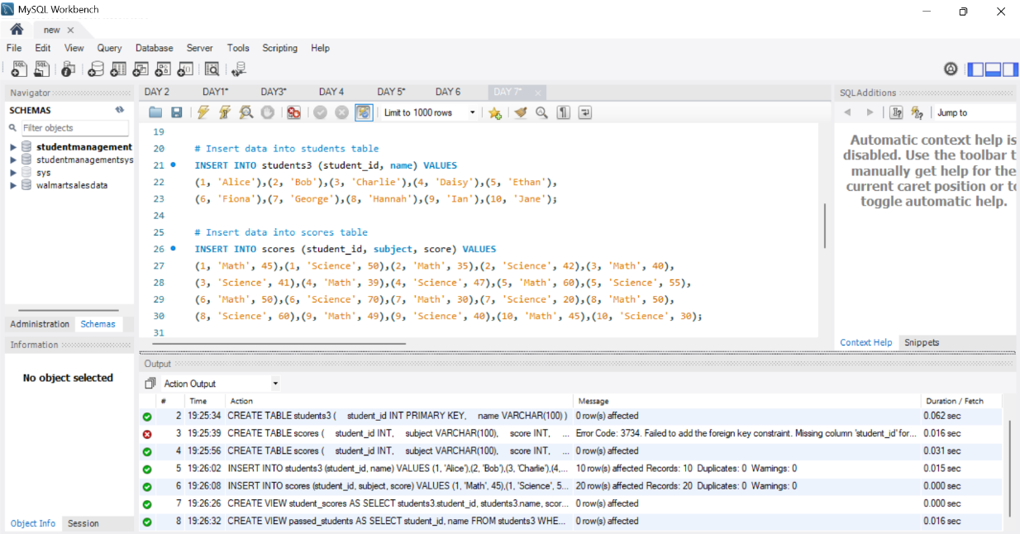

Create a View for Students Who Passed All Subjects

Objective: Show students who passed all subjects (e.g., passing score ≥ 40).

**Query**:

CREATE VIEW passed_students AS

SELECT student_id, name

FROM students3

WHERE student_id NOT IN (

SELECT student_id FROM scores WHERE score < 40

);

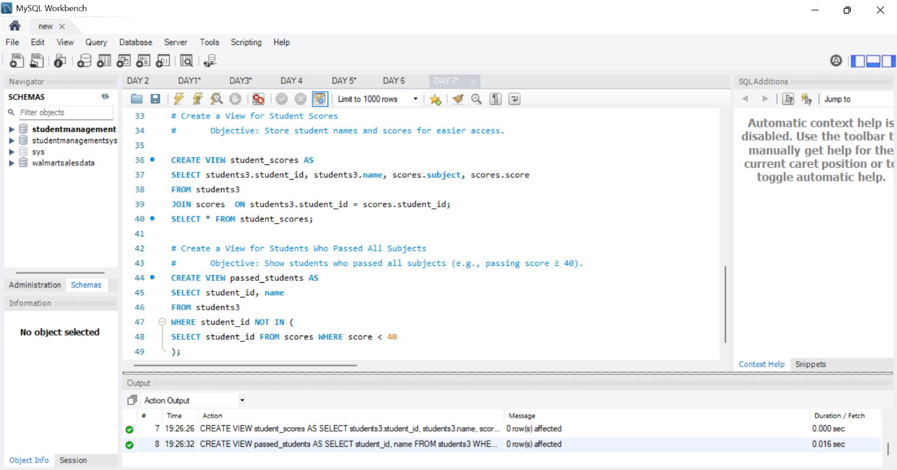

**Query Utilization**

1. Enhance database efficiency by creating views for student scores and pass status.
2. Simplify data access by storing student names and scores in a view for easier retrieval.
3. Identify students who passed all subjects with a score of 40 or higher

**Key Findings:**

Streamlined Query Execution: The views facilitate streamlined query execution, avoiding the need to rewrite complex join or filter conditions.

Student Performance Insights: The student_scores view offers a comprehensive look at student performance across subjects, allowing for easy analysis and reporting.

Pass/Fail Analysis: The passed_students view provides a clear list of students who have passed all subjects, simplifying the assessment of overall academic performance

**Main Flow Services and Technologies Pvt. Ltd.**

* **Contact No.:** +91 9389641586, +91 97736 99074
* **Email:** contact.mainflow@gmail.com
* **Website:** www.mainflow.in